**LAB 7 REPORT – Aaron Bruner**

The purpose of this lab is to calibrate a camera using the Matlab computer vision application. Using a 30mm square matrix and Matlab we can calibrate the camera. Below are the images that were collected:

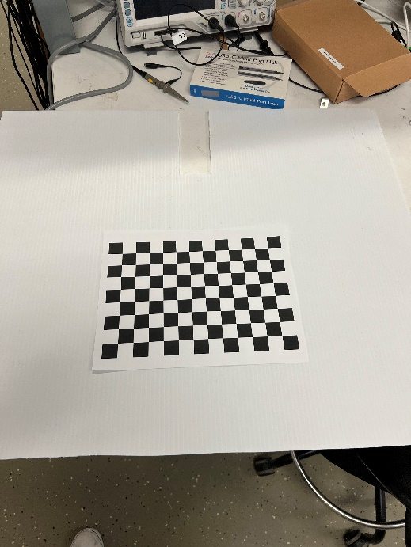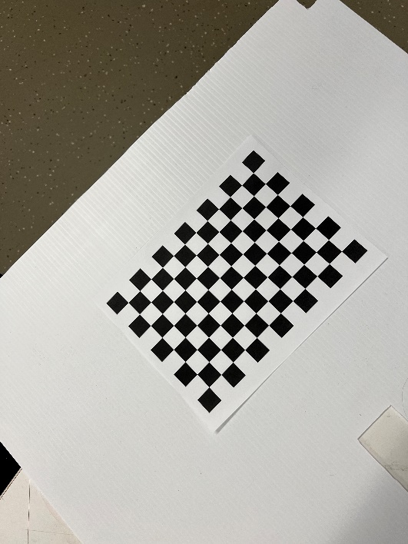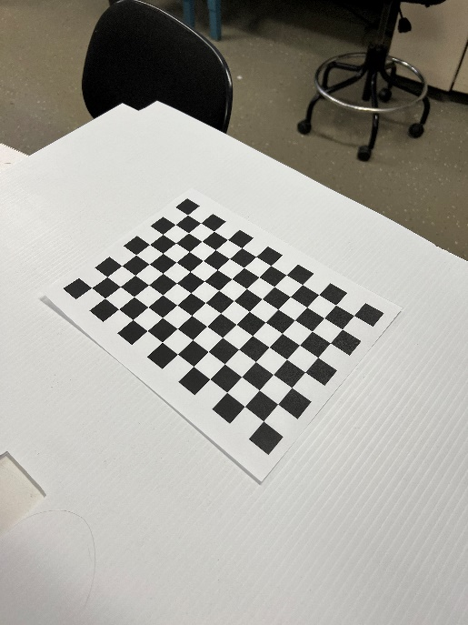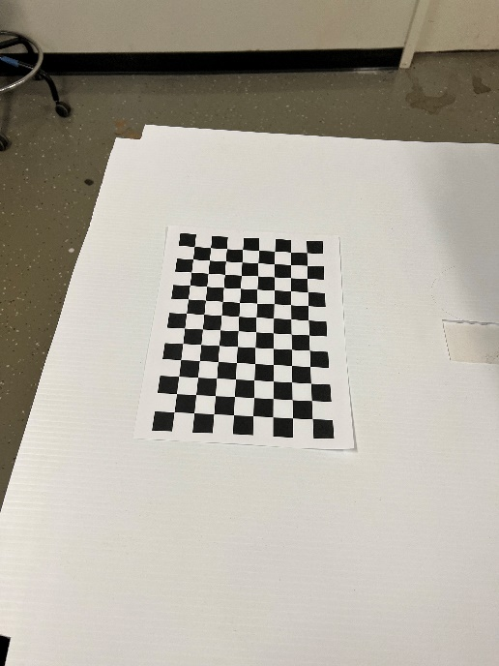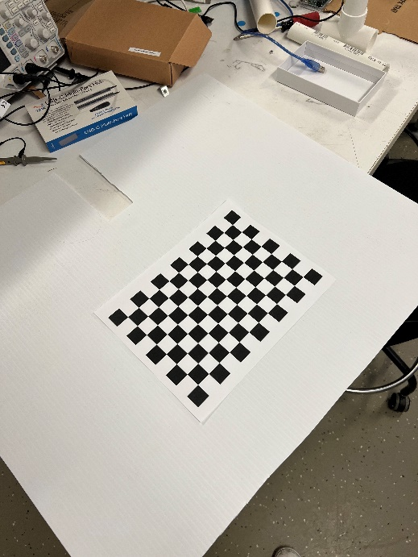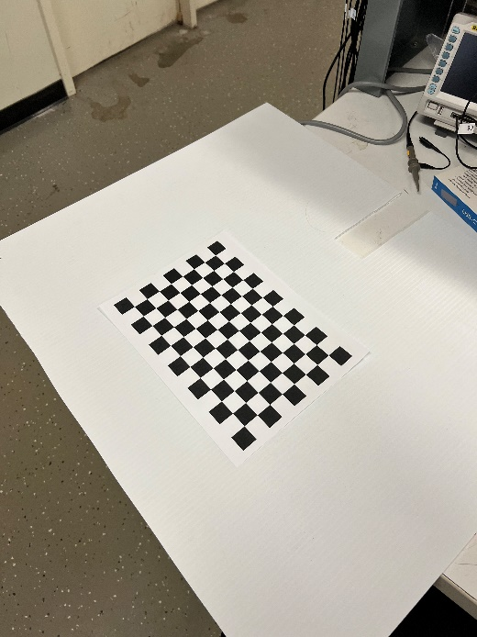

After running calibration the following images are collected:

Projection Errors:

Extrinsic Parameter Visualization:

Pattern Centric Visualization:

Camera Parameters:

|  |  |  |  |
| --- | --- | --- | --- |
|  | **X** | **Y** | **Z** |
| **Image 1** | **224.64** | **-28.939** | **730.57** |
| **Image 2** | **-72.5344** | **-159.1954** | **822.4587** |
| **Image 3** | **-107.9774** | **126.9927** | **775.4716** |
| **Image 4** | **215.0745** | **5.4299** | **945.9497** |
| **Image 5** | **-41.3533** | **-127.2435** | **1054.4** |
| **Image 6** | **-179.3163** | **-35.9867** | **943.6473** |